Report by: 1409046  
Role: Level Design & Artist liaison

Game Version: Latest – with Menus  
Date Reported: 20/04/2016

QA Status: Passed

Severity: Minor

Priority: Low

Test Introduction:

Here I wanted to test that the speed and tilt were correctly balance to make the game playable and fun. To test this, I tried to play the game start to finish.

Expected outcome:

I expected the ship to move swiftly down the track to avoid object and to be destroyed when colliding with obstacles.

Actual outcome:

When I ran the game at the start everything was running smoothly, after around the halfway point of the track the speed was so great that the ship would just fly straight through obstacles, at this speed it also became too hard to control the ship

Screenshot of the bug:

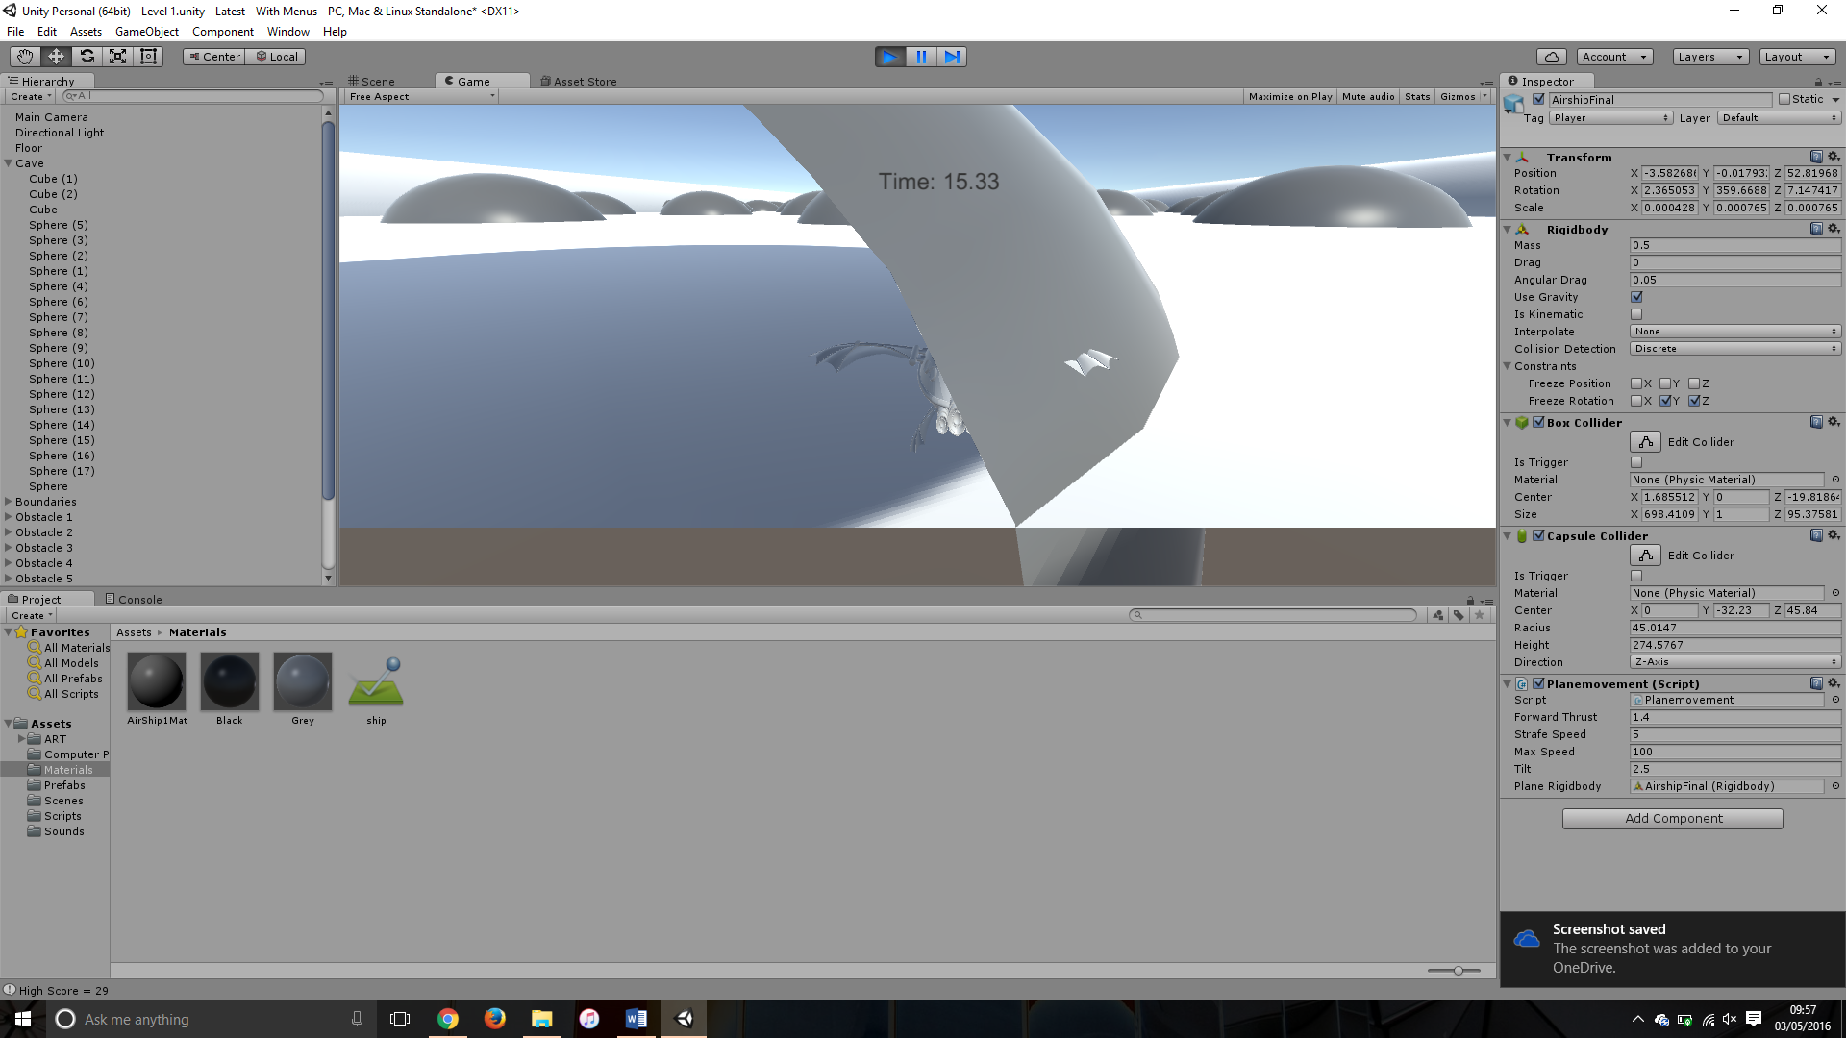

Image showing ship object going through the obstacle due to the high speed

Potential cause:

A potential cause of this could be that because the model is moving so fast the collision detection system does not pick it up and therefore the ship keeps moving unharmed.

Suggested Fix:

To fix this bug I would suggest putting a maximum speed onto the player movement script, this will also make it easier to manipulate the tilt as I would then know the maximum speed it will get. This will be outsourced to developer of player movement.